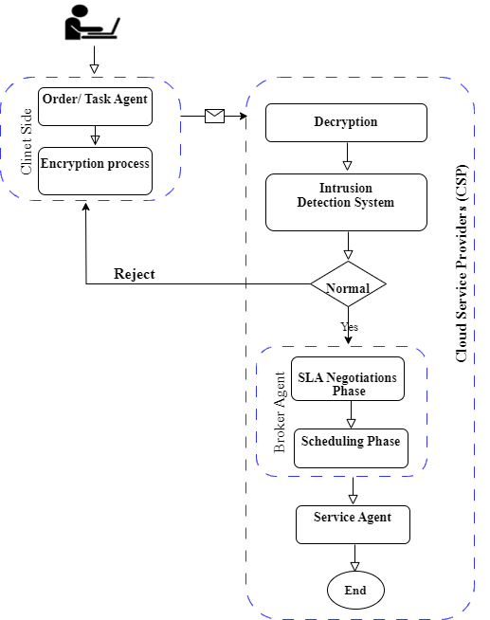

**Figure 3.1: General Architecture of secure Resource Allocation in Cloud**

1. **توليد ال request**
2. **تشفير**
3. **ارسال**
4. **فك التشفير**
5. **فحص ال IDS**
6. **تخصيص المصادر**